**Test on 20-12-2024**

1. **What is devops ?**

Devops is a basically Software development strategy which bridges the gap Between the deaf side(Development) offside(Operation) of the company. So devops is basically a term for a group of concepts that while not all half catalyse into a movement and a rapidly. Devops is a methodology to study of building evolving &operating rapidly changing system at scale.

DevOps the process of Delivering the product or project by ensuring automation in place ensuring the quality with continuous Monitoring and continuous testing.

1. **Why devops?**

To deliver the software (or) project (or) product on Time.

**Faster Time to Market**  DevOps such as continuous integration and continuous delivery (CI/CD), enable organizations to release software more frequently and rapidly.

Reduced Time to Resolution Automated processes and efficient workflows help to quickly identify and fix issues, minimizing downtime.

Faster Feature Delivery Customers benefit from timely updates and new features.

**Enhanced Reliability:** Fewer outages and faster issue resolution lead to a better customer experience.

By implementing DevOps practices, organizations can achieve a competitive advantage, deliver higher-quality software, and respond more effectively to market demands.

Some real time examples:

**Netflix:**

1. **What is need of devOps?**

DevOps is a cultural and technical approach that integrates development (Dev) and operations (Ops) teams to improve collaboration, streamline workflows, and deliver software faster and more reliably. Here's why DevOps is needed:

* Faster Software Delivery
* Improved Collaboration and Communication
* Enhanced Software Quality
* Increased Reliability
* Scalability
* Cost Efficiency
* Better Security
* Adaptability to Market Changes
* Reduced Risk
* Competitive Advantage

1. **What are the devOps tools?**
2. Planning/coading/SCM: **Git,Jira**
3. Building code: **Maven, Gradle,apache ANT**
4. Testing: **Selenium testing with python**
5. Integration: **Jenkins (CI/CD)**
6. Deployment: **Dockers, Kubernates**
7. Operations**: Ansible—(Managing)**
8. Monitoring: **Teraform**
9. **Difference b/w break continue and pass ?**

In Python, break, continue, and pass are control flow statements used to influence the execution of loops or blocks of code.

**1. break:**

The break statement in python is used to terminate the loop or statement in which it is present.

Example:

for i in range(5):

if i == 3:

break

print(i)

# Output: 0 1 2

2.**continue:**

Continue is also a loop control statement just like the break statement. continue statement is opposite to that of the break statement, instead of terminating the loop, it forces to execute the next iteration of the loop.

Example:

for i in range(5):

if i == 3:

continue

print(i)

# Output: 0 1 2 4

**3.pass:**

The pass statement in Python is used when a statement is required syntactically but you do not want any command or code to execute.

Example:

for i in range(5):

if i == 3:

pass

print(i)

# Output: 0 1 2 3 4

**Differences**

| **Aspect** | **break** | **continue** | **pass** |
| --- | --- | --- | --- |
| **Function** | Exits the loop entirely. | Skips to the next iteration. | Does nothing; placeholder. |
| **Effect on Loop** | Terminates the loop. | Skips current iteration. | No impact on the loop. |
| **Common Use** | Stopping loops early. | Skipping specific iterations. | Placeholder in loops or blocks. |

1. **d/w remove , delete, pop and write an example program in python to demonstrate 3 of them.?**

**1.Remove:** Removes the first occurrence of a specified value in a list.

•

list=["archana", "Rachana", "Madhu", "Chaithu", "Thrisha"]  
list.remove("archana")  
print(list)

output: ['Rachana', 'Madhu', 'Chaithu', 'Thrisha']

**2.Delete:** Deletes an element at a specific index or the entire object.

list=["archana", "Rachana", "Madhu", "Chaithu", "Thrisha"]  
del list [1]  
print(list)

output: ['archana', 'Madhu', 'Chaithu', 'Thrisha']

**3.pop():** Removes and returns an element at a specific index (default is the last item).

list = ["archana", "Rachana", "Madhu", "Chaithu", "Thrisha"]  
item = list.pop(1)   
print(list)

output: ['archana', 'Madhu', 'Chaithu', 'Thrisha']

**7.D/w append and extend..?**

**1.append() :** Adds a single element (object) to the end of the list.

list = ["archana", "Rachana", "Madhu", "Chaithu", "Thrishan"]  
list.append("Chikky")  
print(list)

output: ['archana', 'Rachana', 'Madhu', 'Chaithu', 'Thrishan', 'Chikky']

**2.Extend()** :Adds all elements of an iterable (e.g., list, tuple) to the end of the list.

list1=["archana", "Rachana", "Madhu", "Chaithu", "Thrishan"]  
list2=["Harsha","Bablu"]  
list.extend(list2)  
print(list)

output: ['archana', 'Rachana', 'Madhu', 'Chaithu', 'Thrishan', 'Chikky', 'Harsha', 'Bablu']

**extend()** and **append()** are two Python list methods used to add elements to a list but they behave quite differently. The **append()**adds a single item or any object, while **extend()**adds each element of an **iterable**to the list. In this article, we’ll explore the differences between**append()**and **extend()**with examples and use cases to help us understand when to use each method.

**8.Write a python program to print the element in the array with negative indexing (ex : print the element which is present in -2 positions) ..?**

array = [10, 20, 30, 40, 50

negative_index = -2

if abs(negative_index) <= len(array):

print(f"The element at position {negative_index} is: {array[negative_index]}")

else:

print(f"Invalid negative index {negative_index} for the array.")

output: The element at position -2 is: 40

**9.Explain about lamda function?**

A lambda function in Python is a small, anonymous function that is defined without a name. Unlike regular functions created using the def keyword, lambda functions are used for short, simple operations and are typically defined in a single line.

Syntax:

lambda arguments: expression

**arguments**: The inputs to the function (can be zero, one, or multiple).

**expression**: The operation performed and the value returned (must be a single expression).

Example:

def add(x, y):

return x + y

add_lambda = lambda x, y: x + y

print(add_lambda(5, 3))

# Output: 8

**10.What is cloud ..? explain top 10 cloud providers ..?**

Cloud computing is a way of providing IT infrastructure to customers, it is not just a set of products to be implemented. For any service to be a cloud service.

On-demand self-service:Decision of starting and stopping service depends on customers without direct interaction with providers.

**1**. Amazon Web Services (AWS)

2. Microsoft Azure

3. Kamatera

4. Alibaba Cloud

5. Oracle Cloud

6. IBM Cloud (Kyndryl)

7. Tencent Cloud

8. OVHcloud

9. DigitalOcean

10. Linode(owned by Akamai)

**11. what is cloud computing and explain types ..?**

**Cloud Computing** means storing and accessing the data and programs on remote servers that are hosted on the internet instead of the computer’s hard drive or local server. Cloud computing is also referred to as Internet-based computing, it is a technology where the resource is provided as a service through the Internet to the user. The data that is stored can be files, images, documents, or any other storable document.

**1.Cloud Computing Service Models**

**2.Cloud Computing Deployment Models**

**1.Cloud Computing Service Models**

* **Infrastructure as a Service (IaaS)**

Definition: Provides virtualized computing resources over the internet. Users get access to virtual machines, storage, networking, and other fundamental computing resources.

* **Platform as a Service (PaaS)**

**Definition**: Provides a platform allowing customers to develop, run, and manage applications without managing the underlying infrastructure. It provides tools, frameworks, and libraries to streamline the development process.

* **Software as a Service (SaaS)**

**Definition**: Delivers fully managed software applications over the internet. Users access software through a web browser, eliminating the need for installation and maintenance.

**2.Cloud Computing Deployment Models**

* **Public Cloud**

**Definition**: Cloud services are delivered over the public internet and shared among multiple organizations. Resources are owned and managed by a third-party cloud service provider.

* **Private Cloud**

**Definition**: The cloud infrastructure is dedicated to a single organization. It can be hosted either on-premises or by a third-party provider. Private clouds offer more control over the resources and data.

* **Hybrid Cloud**

**Definition**: A combination of both public and private clouds, allowing data and applications to be shared between them. It provides greater flexibility, as businesses can run sensitive workloads in a private cloud while using public cloud for less-critical tasks.

**12. what are the different levels of cloud storages ..?**

* Cold storage: Low-cost, long-term archival storage, infrequent access.
* Object storage: For infrequent access data, lower cost than hot storage.
* File storage: Stores data in a file system structure, ideal for shared access.
* Block storage: Stores data in blocks, ideal for high-performance apps
* Hot storage: High performance for frequently accessed data.
* Warm storage: For infrequent access data, lower cost than hot storage.
* Deep archive: Very low-cost storage for archival data that is almost never.

**13. explain the architecture of service model with real time examples?**

Cloud computing offers various service models, each with its own architecture . The primary service models are:

1. **Infrastructure as a Service (IaaS)**

**Aws azure**

1. **Platform as a Service (PaaS)**
2. **Software as a Service (SaaS)**

Real-Time Example:

* **Salesforce**: A leading SaaS CRM platform that offers sales, service, and marketing solutions. Users access the software through a web interface, with Salesforce handling all infrastructure and software updates.

**14. explain deployment model?**

* **Public Cloud**

**Definition**: Cloud services are delivered over the public internet and shared among multiple organizations. Resources are owned and managed by a third-party cloud service provider.

* **Private Cloud**

**Definition**: The cloud infrastructure is dedicated to a single organization. It can be hosted either on-premises or by a third-party provider. Private clouds offer more control over the resources and data.

* **Hybrid Cloud**

**Definition**: A combination of both public and private clouds, allowing data and applications to be shared between them. It provides greater flexibility, as businesses can run sensitive workloads in a private cloud while using public cloud for less-critical tasks.

**15. mention few differences b/w AWS , MICROSOFT AZURE , AND GCP?**

Aws:

Market share: Largest, leader in cloud market

Compute services: Amazon lambda EC2

Storage: S3, EBS, Glacier

Databases: RDS, DynamoDB, Aurora

Networking: VPC, Direct Connect

Hybrid cloud: Strong hybrid support via VMware Cloud, Outposts

Security Compliance: Strong security and compliance offerings

Best for: Large scale, diverse workloads

Microsoft Azure:

Market share: Second-largest, strong in enterprise

Compute services: Azure Virtual Machines, Azure Functions

Storage: Blob Storage, Disk Storage

Databases: Azure SQL Database, Cosmos DB

Networking: Virtual Network, Load Balancer

Hybrid cloud: Azure Stack, Hybrid integration

Security Compliance: Strong security and compliance

Best for: Enterprises, Microsoft ecosystem

Google cloud platform:

Market share: Smaller, but growing rapidly

Compute services: Google Compute Engine, Cloud Functions

Storage: Cloud Storage, Persistent Disks

Databases: Cloud SQL, Bigtable, Firestore

Networking: VPC, Cloud Load Balancing

Hybrid cloud: Anthos for Kubernetes management

Security Compliance: Strong focus on data privacy, GDPR

Best for: Data analytics, AI/ML, and containers

**16. Write a python program to print your name , designation, technology 100 times ?**

Example:

name = "Archana"  
designation = "Intern"  
technology = "Devops"  
  
for _ in range(100):  
 print(f"Name: {name}, Designation: {designation}, Technology: {technology}")

Name: Archana, Designation: Intern, Technology: Devops

**17. d/w agile and waterfall models..?**

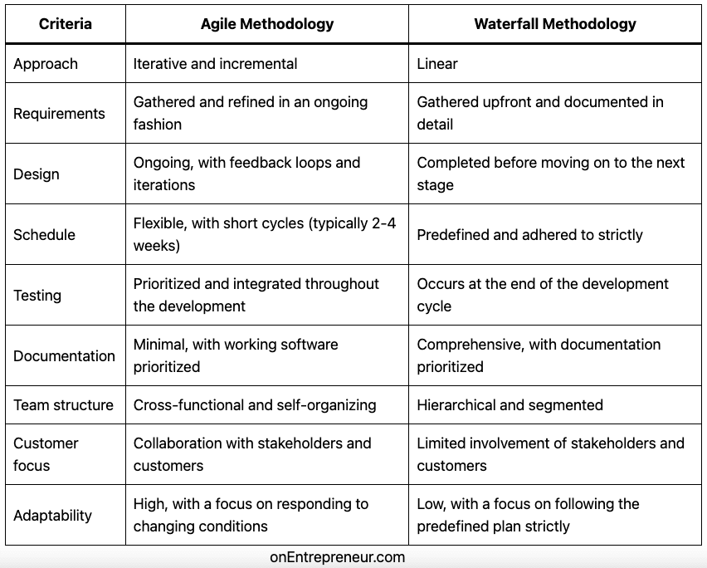

**18. explain about arithmetic and relational operators with example..?**

**Arithmetic:** Arithmetic operators are used to perform mathematical operations such as addition, subtraction, multiplication, division, and more**.***# 1. Addition (+)*a = 10  
b = 5  
print (a + b)  
*#print(result) # Output: 15  
  
# 2. Subtraction (-)*a = 10  
b = 5  
print (a - b)  
*#print(result) # 10-5 Output: 5  
  
# 3, Multiplication (*)*a = 10  
b = 5  
print(a * b)  
*#print(result) # Output: 50  
  
# 4. Division (/)*a = 10  
b = 5  
print(a / b)  
*#print(result) # Output: 2.0  
  
# 5. Floor Division (//)*a = 10  
b = 5  
print(a // b)  
*#print(result) # Output: 2  
  
# 6. Modulus (%)*a = 10  
b = 5  
print( a % b)  
*#print(result) # Output: 0  
  
  
# 7. Exponentiation (**)*a=10  
b=5  
result= a**b  
*#print(result) #output=100000*

**relational operators:** Relational (or comparison) operators are used to compare values. They return a boolean value (True or False) depending on whether the comparison is true or false.

x = 10  
y = 5  
  
print(x == y) *# Output: False*print(x != y) *# Output: True*print(x > y) *# Output: True*print(x < y) *# Output: False*print(x >= y) *# Output: True*print(x <= y) *# Output: False*

**19. compares b/w set, list, tuple and dictionary ?**

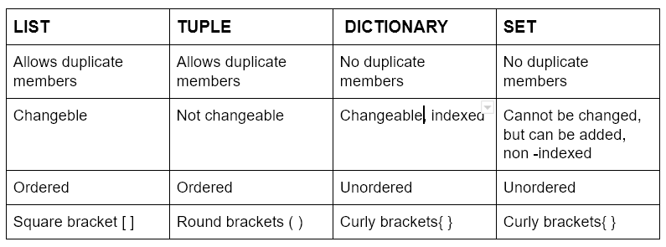

**20. Explain the phases involved in software development life cycle..?**

Software Development Life Cycle, and it's a structured process that is used to design, develop, and test good-quality software, and maintain software. The goal of SDLC is to create high-quality software that meets customer expectations in a cost-effective and timely manner.

1. Planning: planning is the first phase of (SDLC) in this phase we plan the whole software system in Budget and in Timely manner and to reach the user Expectation.

2. Requirement Analysis: This is the second phase of (SDLC) the requirement analysis is to mainly depends on the user requirements and that is taken from the customer to built a software project.

3. Design: This is the third phase of (SDLC) **:** Designing the overall architecture of the software system, including its components and their interactions.

4. Development: This is the fourth phase of (SDLC)Writing the actual code for the software components based on the design specifications .Implementing the code using appropriate programming languages and tools. Testing individual software components to ensure they function correctly.

5. Testing: This is the Fifth Phase of (SDLC)Testing the interaction and integration of different software components. Testing the entire software system to ensure it meets the specified requirements. Testing the software by end-users to verify its usability and suitability for their needs.

6. Deployment: This is the sixth phase of (SDLC) in this phase is after releasing the product in the User if any bugs or errors are occur in the Software that is to helps to be corrected in the deployment phase.

7. Maintainance: This is the seventh Phase of(SDLC) that is Fixing bugs and errors identified in the software.

Adaptive Maintenance**:** Modifying the software to adapt to changes in the environment or user needs. Perfective Maintenance**:** Enhancing the software's performance, usability, or functionality. Preventive Maintenance**:** Implementing measures to prevent future problems and improve the software's reliability

**21. what is database ? what is dbms and explain types of dbms ?**

**what is database:**

It is an applicationnwhich stores the collection of data.

* Each database has one or more distinct APIs for creating the data managing the copy data, Searching the data & also replicating in the data.
* File_unchange/can’t update /can’t organization the data in the files.

**What is DBMS:**

Data base management system is store the data in the form of tables.

**Types of Database:**

**1.RDBMS:** Relational data base management system it stores the data in form of tables can also map them in the one location to another .

**2.Non RDBMS**: It stores the data in the form of key- value(j-son format)(server(platform).

**22. what are ddl and dml commands mention example of each one ?**

Mysql uses 2 types of commands:

1. DDL: Data definition language
2. DML: Data manipulation language

**DDL: Data definition language :**

* Create: to create a database, tables.
* Alter: Update---> add a row or column we use alter.
* Drop: Delete the records from the Database( total delete)
* Truncate: removes the records from the tables.
* Rename: rename the table or records in the existing Database

Example:

CREATE TABLE Employees (

EmployeeID INT PRIMARY KEY,

FirstName VARCHAR(50),

LastName VARCHAR(50),

Department VARCHAR(50),

Salary DECIMAL(10, 2)

);

-- ALTER the table to add a new column

ALTER TABLE Employees

ADD Email VARCHAR(100);

DROP the table

DROP TABLE Employees;

TRUNCATE the table

TRUNCATE TABLE Employees;

RENAME the table

RENAME TABLE Employees TO Staff;

**DML: Data manipulation language:**

* Insert: Insert data into a table
* Update: updates the existing data within table
* Delete: delete the records from the Database table
* Call: PL/SQL, java programming
* Explain call

Example:

INSERT data into the table

INSERT INTO Employees (EmployeeID, FirstName, LastName, Department, Salary)

VALUES (1, 'John', 'Doe', 'IT', 50000.00);

UPDATE data in the table

UPDATE Employees

SET Salary = 55000.00

WHERE EmployeeID = 1;

DELETE data from the table

DELETE FROM Employees

WHERE EmployeeID = 1;

SELECT data from the table

SELECT * FROM Employees;

**23. what are clauses and explain with example?**

Clauses in SQL define specific components, actions, or conditions that determine how the query retrieves, manipulates, or filters the data.

Some of the SQL clauses:

**SELECT** : It is to display / to obtain the data from particular table

Ex:Select * from student

**WHERE**: It is used to exact particular record in a table

Ex : select * from student where marks>60

**GROUP BY** : It groups the data present in the rows with same value

Ex: Select sid,sname from student where marks>60 groupby marks order by sid

**ORDER BY** :Used for sorting the records in the table

Ex: Select * from student order by sid

**JOIN Clauses** :Joins are used with select statement used to retrieve data from multiple tables from the same database.

**Two tables**: orders and products joining by their productid

Ex :Select orderid,ordername,productname from orders join products on orders.productid=product.productid

**LIMIT Clause**:To specify only particular number of records to return

Ex:Select sid,sname from studentwhere marks>80 limit 2;

**24. explain the concept of joins with examples?**

Joins are used with select statement.It is used to retrieve data from multiple tables from same database.

It is easy to fetch the records from different tables easily

We have 3 types of joins

**1.Inner Join:**In order to return all the rows from multiple tables where join condition is satisfy.

**2.Left Outer Join**: (Outer Join):Returns all rows from left hand side table and all the rows from the right hand side by satisfying the join condition.

3.**Right outer Join**: (Right Join)::Returns all rows from right hand side table and all the rows from the left hand side by satisfying the join condition

**25. create a trigger and explain?**

Triggers are the SQL codes that are automatically executed in response to certain event on a particular table. This are used to maintain the integrity of the data.

Syntax:

Create Trigger Trigger_Name

(Before|After)

[Insert|Delete|Update]

On[Table_Name]

[for each row|for each column]

[Trigger_body]

Example:

Create Trigger sample_trigger

Before insert

On student

For each row

Set new.marks=new.marks+6;

Before:

Create Trigger calculate

Before insert

On student

For each Row

Set new .marks=new.marks+100;

After:

Create Trigger total_marks

After insert

On Student

For each Row insert into final_mark values(new.marks);